

Foundations of Programming
Assignment No. : 11

PROBLEM STATEMENT:
Write a program in C to accept a number from the user and compute the following:
- Square root of the number
- Square of the number
- Cube of the number
- Check whether the number is prime
- Factorial of the number
- Prime factors of the number

OBJECTIVE:
• To understand the use of mathematical operations in C.
• To implement loops and conditional statements
. • To perform number-based computations.
• To enhance logical thinking using menu-driven programs.

THEORY:
Numbers and their mathematical properties play a vital role in programming. Operations such as square, cube, and square root are basic mathematical computations. Prime number checking involves verifying whether a number has exactly two divisors. Factorial is calculated by multiplying a sequence of integers. Prime factorization breaks a number into its prime components. In C programming, these operations can be efficiently implemented using loops, conditional statements, and mathematical functions.

PLATFORM:
Linux

ALGORITHM:

C PROGRAM:
#include<stdio.h>
#include<math.h>

int main() {
int n, ch, i, c; long long f;
printf("Enter number: "); scanf("%d", &n);
printf("1.Sqrt 2.Sq 3.Cube 4.Prime 5.Fact 6.PrimeFactors\nChoice: "); scanf("%d", &ch);

switch(ch) {
case 1: if(n<0) printf("Error\n"); else printf("%.2f\n", sqrt(n)); break;
case 2: printf("%d\n", n*n); break;
case 3: printf("%d\n", n*n*n); break;
case 4: c=1; if(n<2) c=0; else for(i=2; i*i<=n; i++) if(n%i==0) c=0;
if(c) printf("Prime\n"); else printf("Not Prime\n"); break;
case 5: f=1; if(n<0) printf("Error\n"); else { for(i=1; i<=n; i++) f*=i; printf("%lld\n", f); } break;
case 6: c=n; if(c<2) printf("None"); else for(i=2; i<=c; i++) while(c%i==0) { printf("%d ", i); c/=i; } printf("\n"); break;
default: printf("Invalid Choice\n");
}
return 0;
}

INPUT AND OUTPUT:
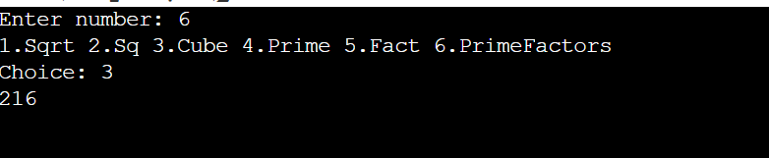

CONCLUSION:
Thus, the program to perform various mathematical operations on a number was successfully implemented using C programming. This program demonstrates the use of loops, conditional statements, switch-case, and mathematical functions.

